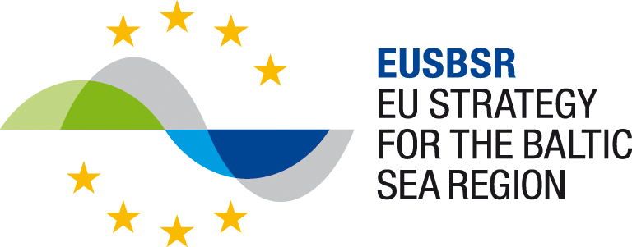



Write in max 2-3 sentences about your project activities planned with the Programme funding to support the implementation of the EUSBSR in aspects of governance, coordination, and communication. Make sure you are understood: use plain English and avoid jargon.
Project site (website of PA, Strategy Forum, BSP)
© Copyright of image
Title
Duration
01/2022 – 12/2024
Total budget
355 000 €
EU funding
284 000 €

