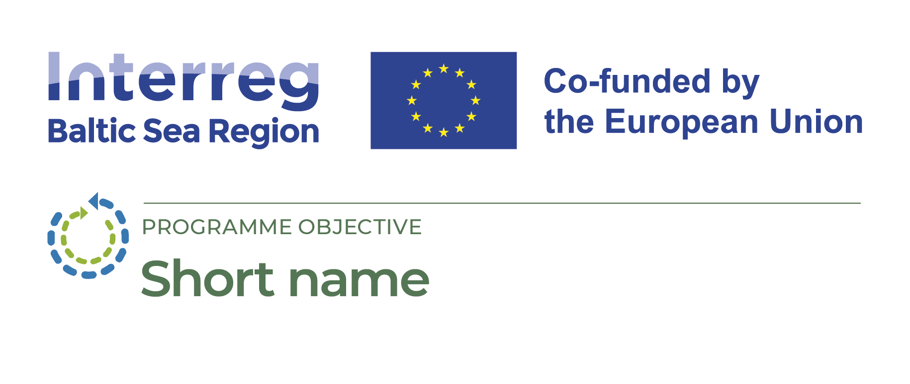
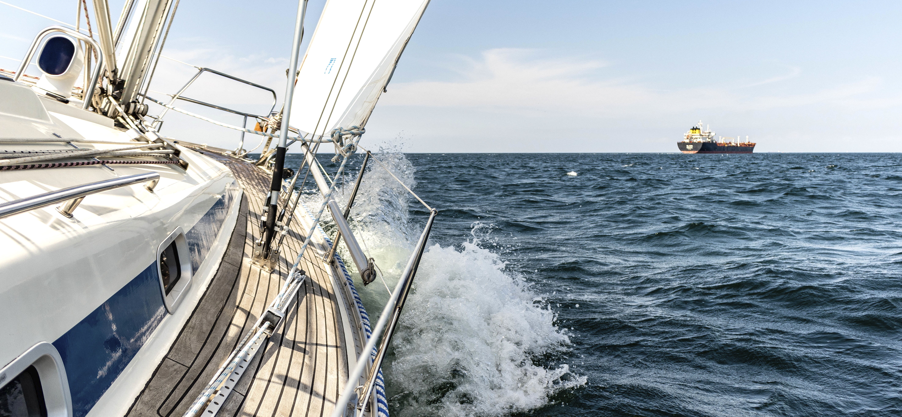

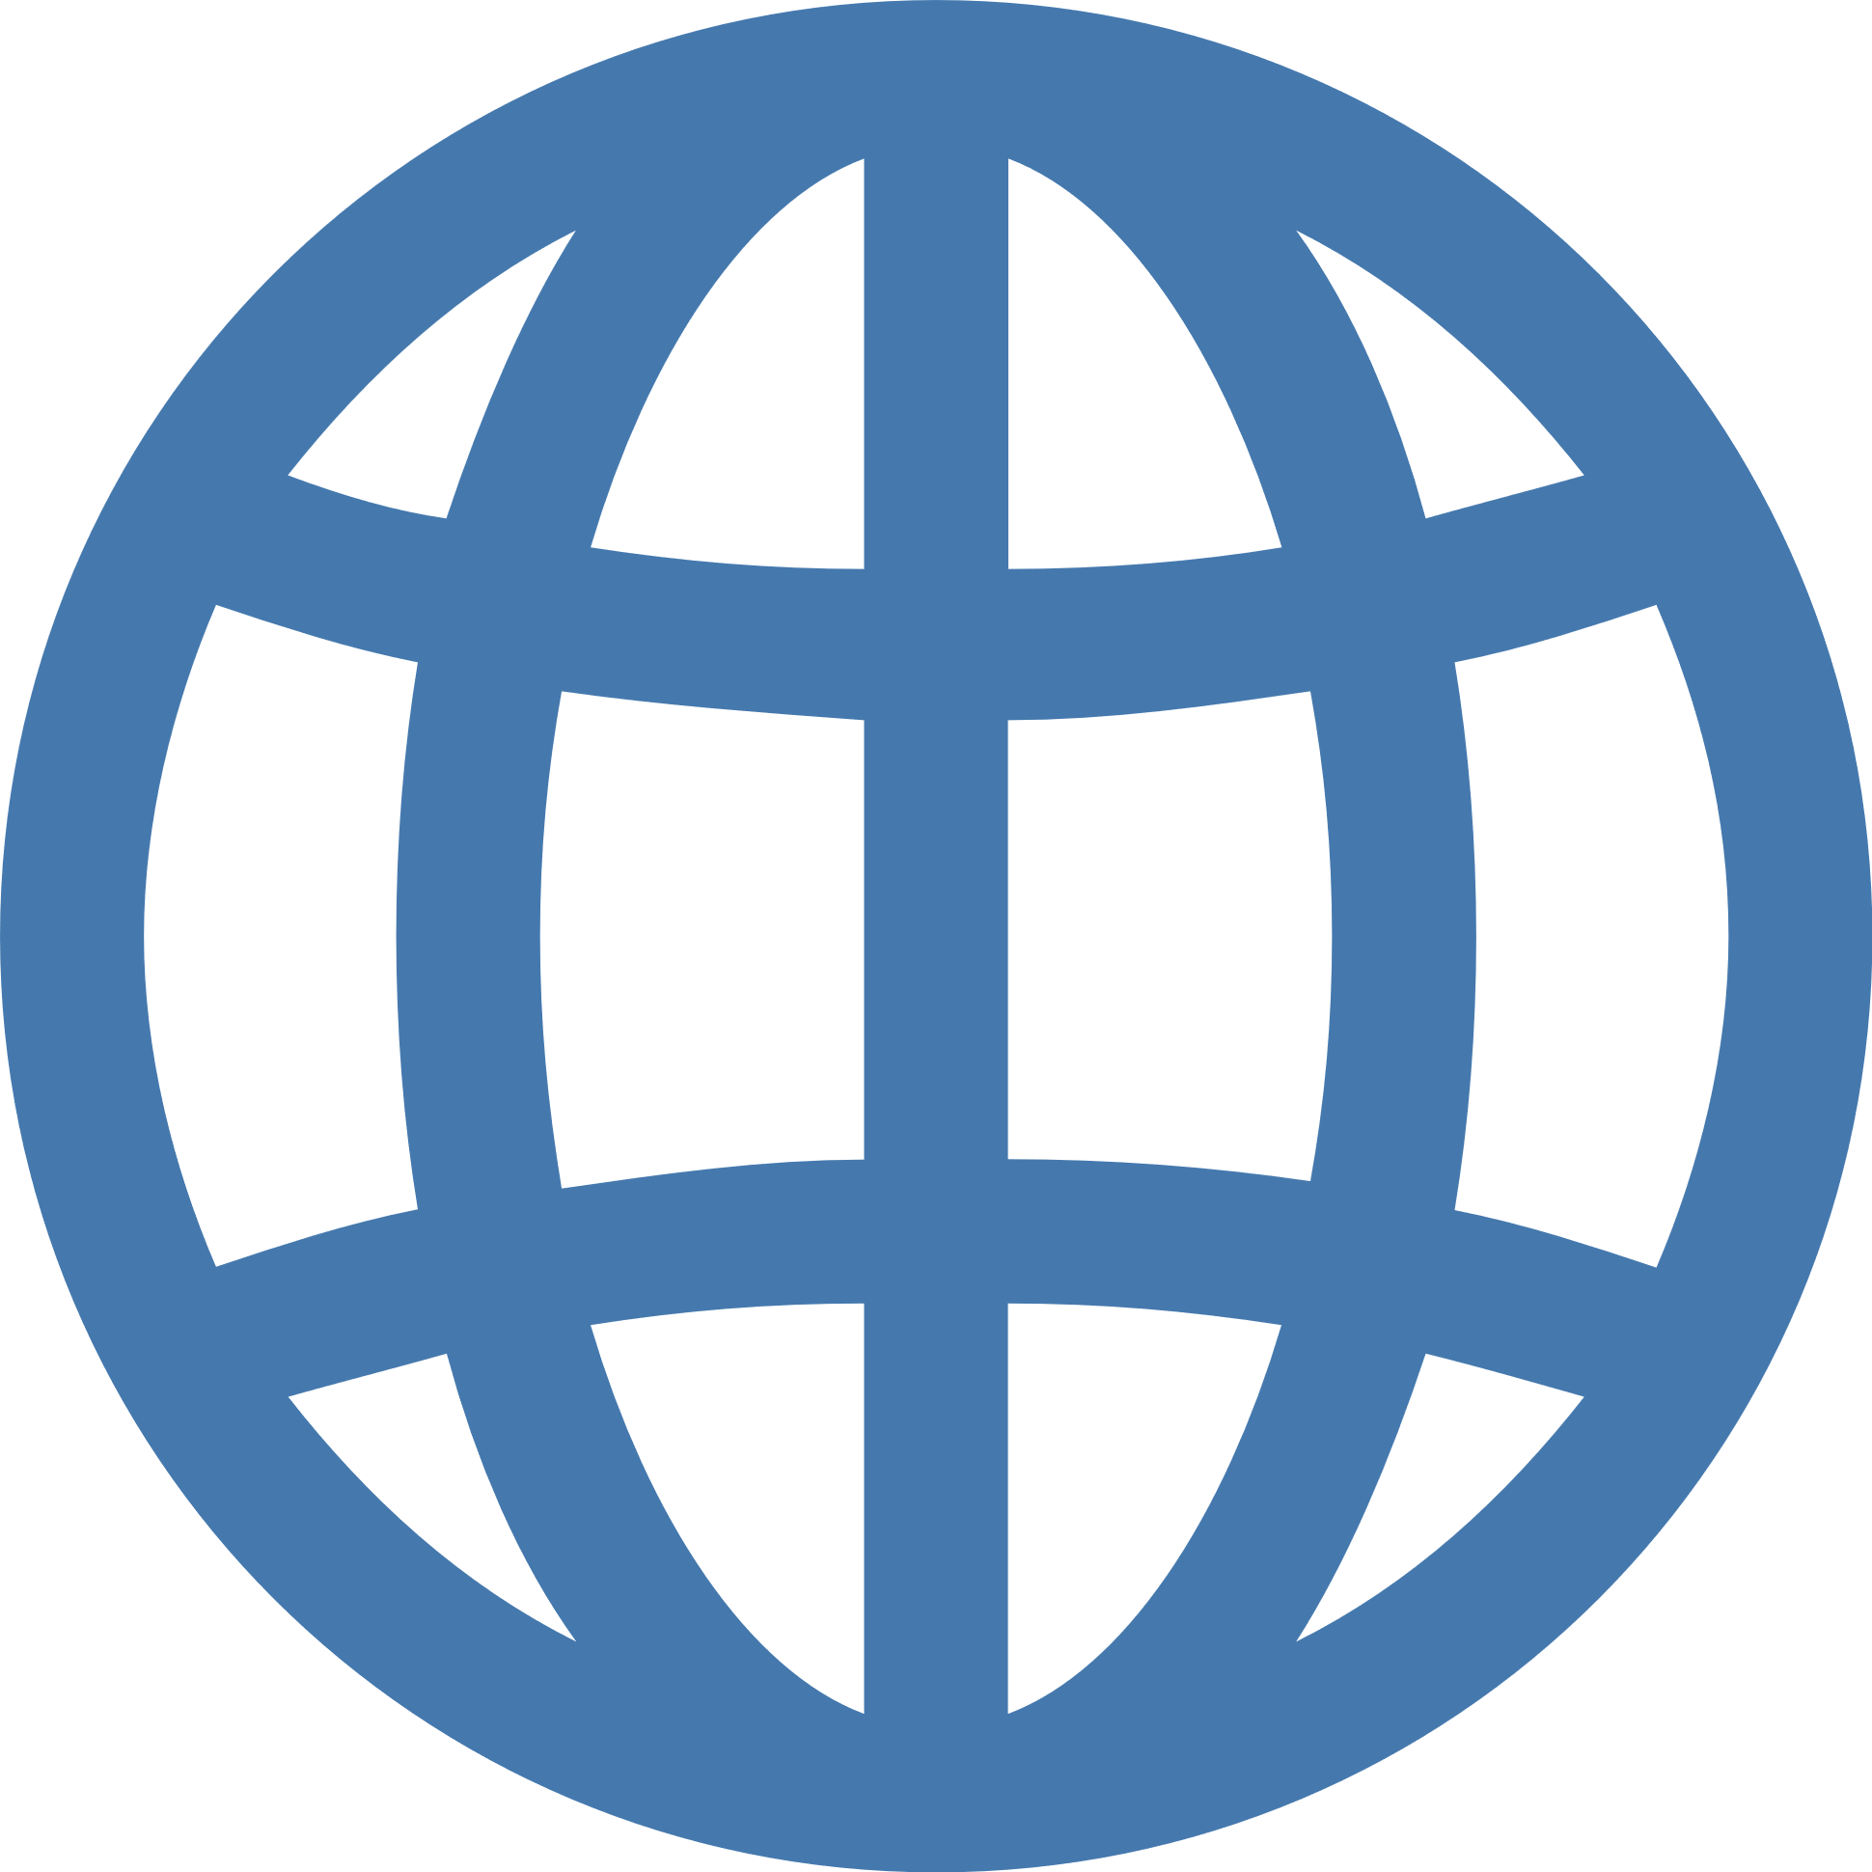
Organisations from the following countries cooperate across borders to make that happen:
XXX, XXX,
Project platform page
This #MadeWithInterreg project platform consolidates the results from XXX projects under Interreg Baltic Sea Region and XXX other programmes.
Write in max 2-3 sentences what your project platform is about, why and how you are consolidating results from different projects/programmes.
Make sure you are understood: use plain English and avoid jargon.

Title
© Copyright of image
Total budget
1 679 000 €
Norwegian funding
1 279 000 €
EU funding
1 279 000 €
Duration
02/2023 – 05/2026

