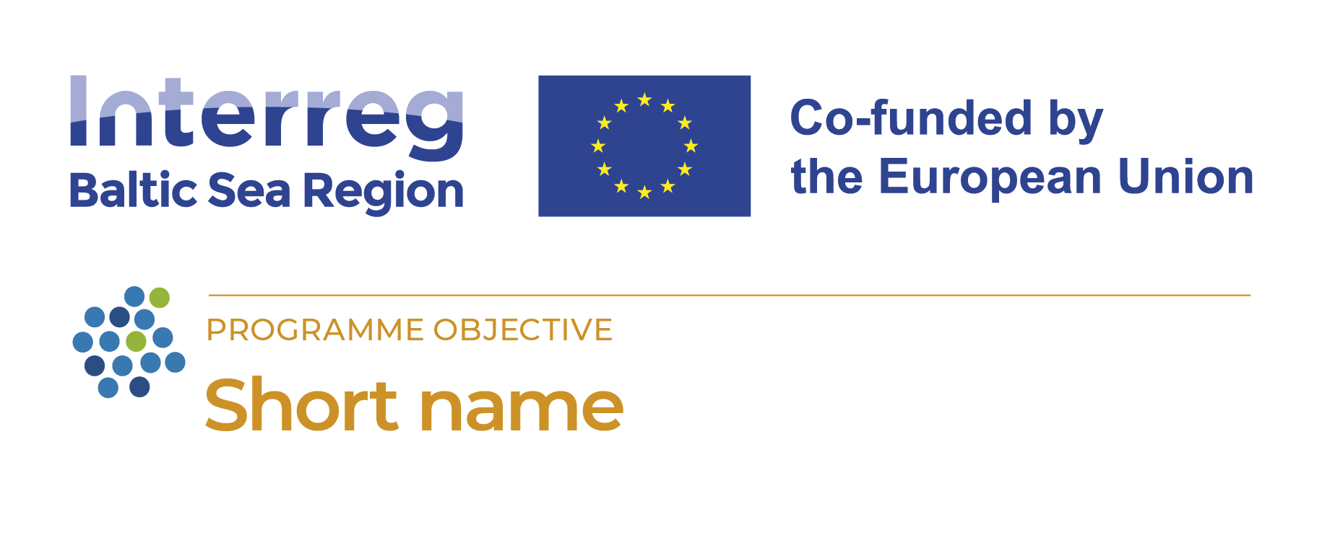
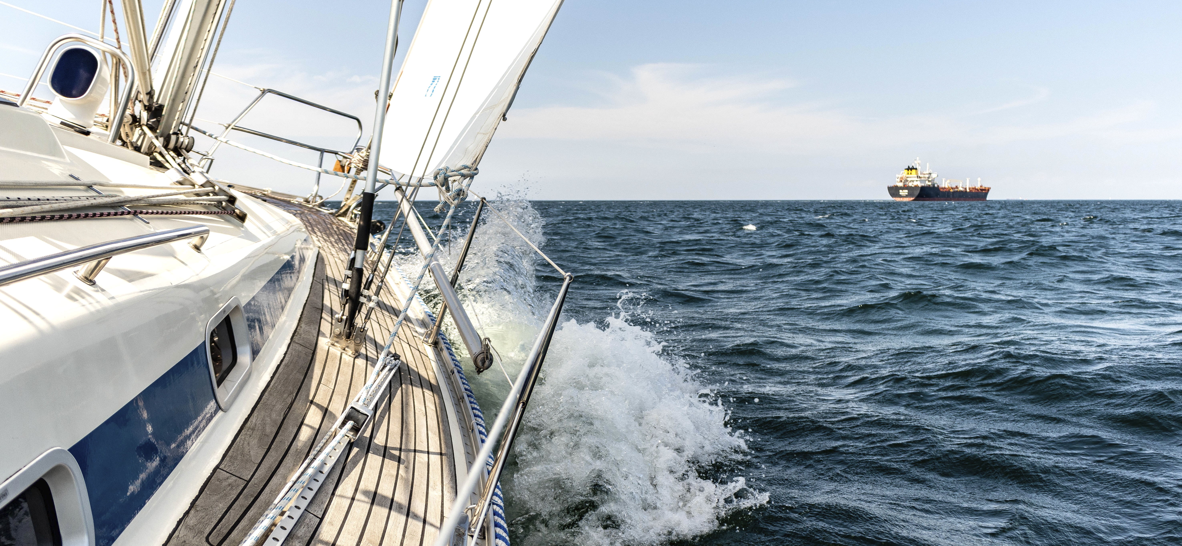
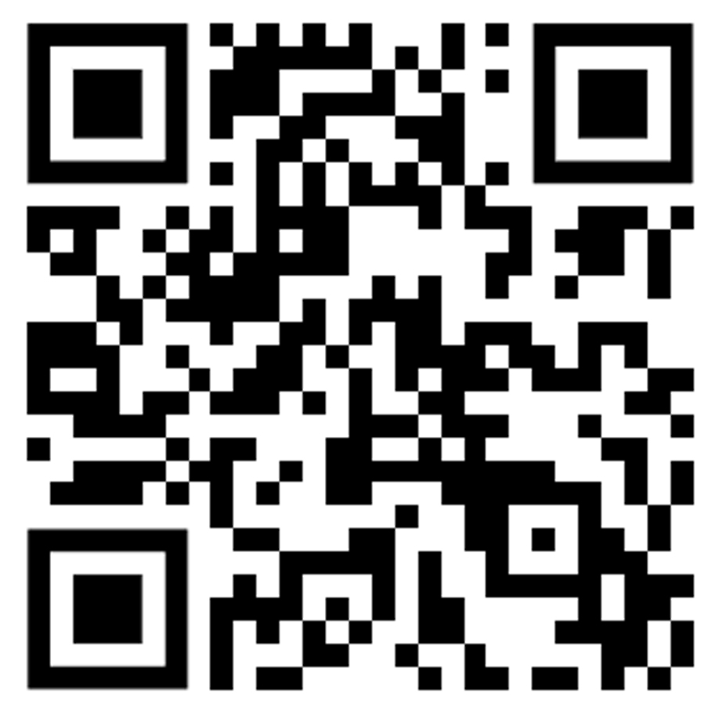
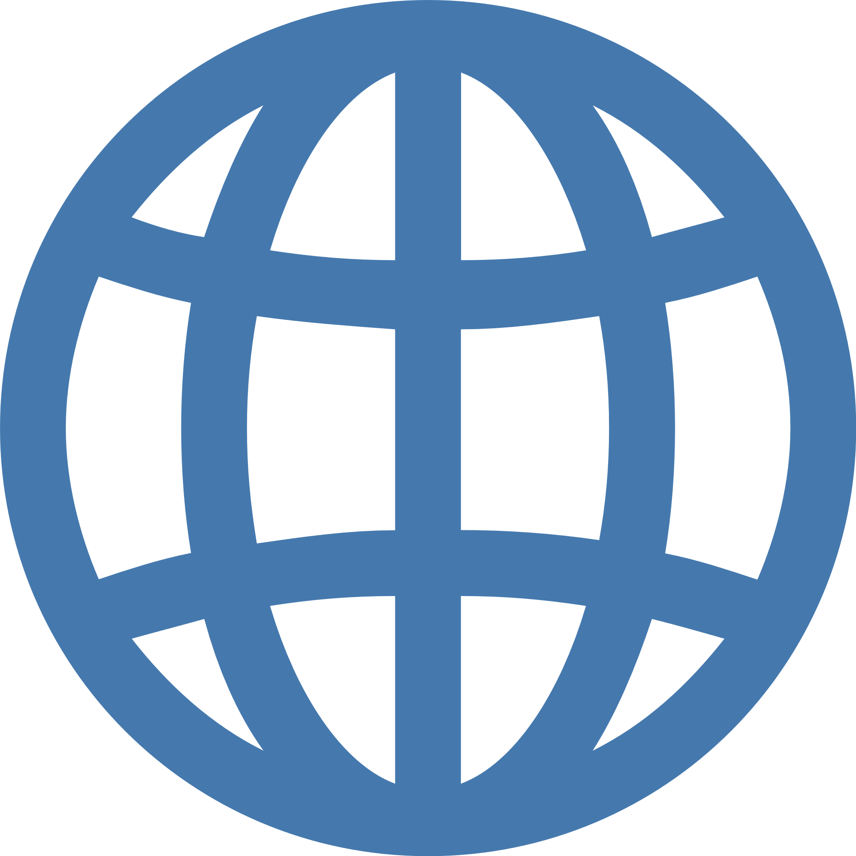
Project page
© Copyright of image
Title
Write in max 2-3 sentences what is your project about: how your project is helping whom and how – and what they can do thanks to you.
Make sure you are understood: use plain English and avoid jargon. You may also highlight support from the funds.
Germany, Poland, Latvia, Lithuania
This #MadeWithInterreg project helps drive the transition to a green and resilient Baltic Sea region.
Organisations from the following countries cooperate together to make that happen:
Total budget
1 679 000 €
Norwegian funding
1 279 000 €
EU funding
1 279 000 €
Duration
02/2023 – 05/2026

