Workshop 3:
Solvolysis of fiber reinforced plastic composite waste report

Krakov 17-18.9.

Table of Contents
CompositeCircle Internal meeting 17.9. : Chemical methods and practical solutions 3
Workshop 3: Solvolysis of fiber reinforced plastic composite waste 5

CompositeCircle Internal meeting 17.9.:
Chemical methods and practical solutions
The third workshop of the CompositeCircle project was held in Krakow, Poland, on September 17–18th. On the first day, an internal project meeting was held, where the project’s progress and various challenges were reviewed in more detail. On the following day, the workshop presented a wide range of industrial solutions for composite recycling. Partners, associated partners, and external speakers were invited to both days. The goal of the internal meeting was to discuss activity progress, challenges, and how to compile the overall work into a guideline/manual, including what is needed for its implementation. The discussion also focused on how to proceed with products and find practical solutions.
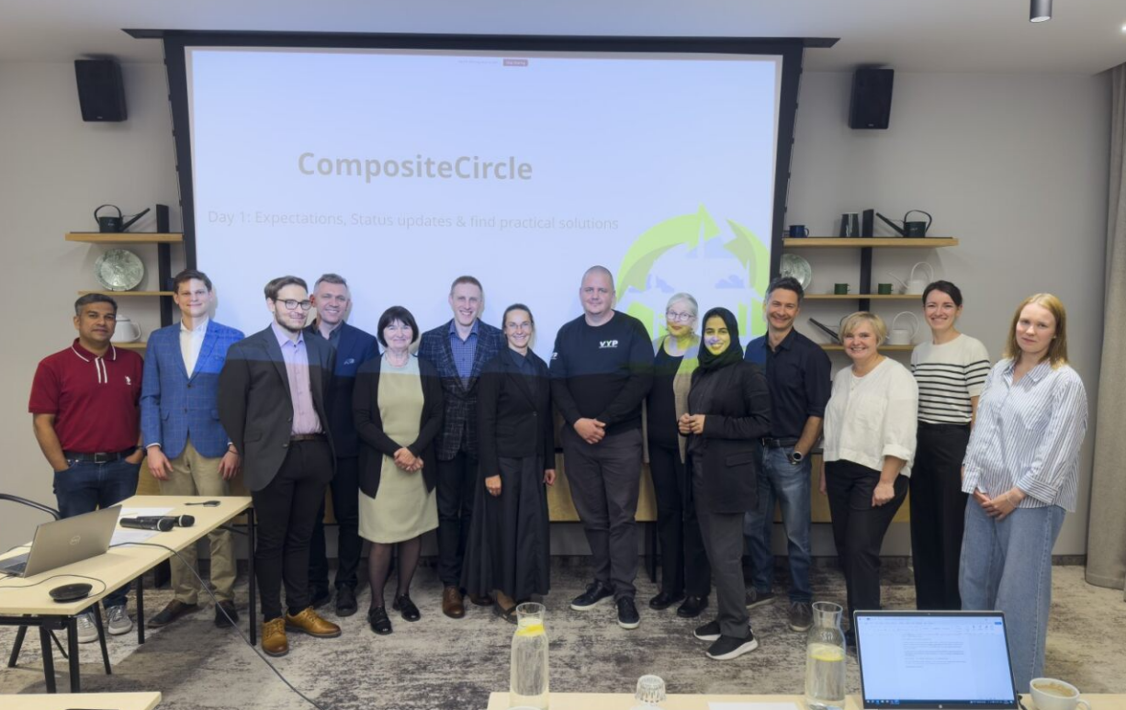
The internal meeting started with Activity 1.2, which highlighted challenges related to the transport, storage, and handling of end-of-life wind turbine blades, as well as partners’ active work in gathering data. The Excel questions on the separation and management of composite waste were reviewed, though some information (e.g., burning composites for heat) is difficult to obtain. Legal aspects were discussed, including turbine recyclability, the need for offshore technology, differences in waste management between countries, and how varying legislation can be combined into a common guide.
Figure 1. A group photo of the project team showcasing the project’s progress.

Activity 1.3: The update covered co-processing and solvolysis progress. Kuusakoski composite waste will be sent to Akmenes Cementas Ltd and Schwenk Latvija, with RTU analysing the samples. Synchronisation with A1.2 activities was discussed. Lab work on solvolysis was presented, including methods, next steps, and curing of epoxy castings. Recovered materials (resin, fibers, solvent) and their potential uses were highlighted, along with challenges, limitations, and commercial solutions. Industries that could adopt mild solvolysis were outlined, as well as integration options such as on-site recycling, regional hubs, and partnerships.
Activity 1.4: The status of the activity and next steps were presented. A cost analysis model has been drafted. Potential industries in the value chain have been identified in each country for future interviews and analysis. Activity 1.5: A draft structure for value chain documentation was presented. A discussion was held on roles and responsibilities within the activity. There was also discussion on having a uniform template for deliverables.
The project’s communication details were presented. GDPR was discussed, including what is subject to it. Project communication was explained, highlighting its importance. A storytelling structure as a form of communication was presented and its use in EU projects was explained: storytelling humanizes research, engages diverse audiences, boosts dissemination, and supports impact. In small groups, storytelling exercises were conducted for the CompositeCircle project to practice the method.

Workshop 3: Solvolysis of fiber reinforced
plastic composite waste

The second day of the event focused on a workshop dedicated to various chemical solutions for composite recycling. The session brought together speakers from several organizations, allowing stakeholders to connect and exchange knowledge more extensively.
The workshop began with an overview of recent advancements in composite recycling opportunities and a general presentation of the CompositeCircle project its objectives, current progress, and upcoming solutions. Following this, the Aarhus University presented on recycling scenarios for fiber-reinforced composites (FRCs). End-of-life wind turbine blades (EoL WTBs) represent a major challenge, as they are mainly composed of glass fiber- (GFRP) and carbon fiber-reinforced polymers (CFRP), whose thermoset matrices hinder reprocessing and decomposition. Alternatives to landfilling include mechanical, thermal, and chemical recycling, as well as co-processing in cement kilns and energy recovery through incineration.
Mechanical recycling involves cutting, crushing, and grinding blades at varying levels of precision, enabling their use in structural applications (e.g., bridges, furniture, road signs) or as ground fibers in secondary products such as 3D printing materials. While simple, cost-efficient, and environmentally friendly, the process produces lower-quality fibers (about 50% of virgin strength) and is energy-intensive. Thermal recycling decomposes the resin at high temperatures: pyrolysis (450–700 °C) can retain up to 80% of fiber strength and is particularly promising for carbon fibers; fluidized bed combustion removes the matrix but weakens fibers; and microwave-assisted pyrolysis (MAP) offers a clean and energy-efficient option, though still at a laboratory stage. Chemical recycling, especially solvolysis, uses solvents to break down the resin, allowing fiber recovery with yields up to 100% of near-virgin quality. However, the method remains expensive and technically demanding. Co-processing in cement kilns is a mature and economically viable option for GFRP, utilizing organic content as fuel and binding inorganic residues into cement, although capacity and emission constraints limit its use. Energy recovery by incineration at 800–1000 °C can generate heat and electricity but leaves up to 60% ash residue and is increasingly viewed as unsustainable, being banned in some EU countries.
The second presentation, “Composite Recycling and the Law: Enabler or Obstacle?” by the State Environmental Service, examined EU and national legislation concerning composite recycling and the transition towards a circular economy. Key policy frameworks discussed included the Waste Framework Directive, Industrial Emissions Directive, Landfill Directive, and Extended Producer Responsibility. National practices such as landfill bans and recycling obligations were also compared. Ongoing projects developing mechanical and chemical recycling methods (e.g., pyrolysis and solvolysis) and new product applications from composite waste were highlighted. The CompositeCircle project (2025–2028) aims to build regional recycling infrastructure across the Baltic Sea area. The session concluded that the EU has the potential to become a global leader in composite recycling provided that regulation evolves to include dedicated waste codes, clear recycling targets, and landfill bans.
Following this, Composite United presented its activities within the framework of the Ecodesign for Sustainable Products Regulation (ESPR), which guides the design of sustainable and circular products across the EU. The organization highlighted the pivotal role of the Digital Product Passport (DPP) as a future tool for collecting and sharing comprehensive product lifecycle data covering materials, manufacturing methods, performance, and recyclability among stakeholders. The DPP defines both how and what information is managed: the “how” refers to digital platforms and standardized data-sharing protocols, while the “what” covers regulatory, technical, and performance-related requirements. Although a unified passport system for composite materials does not yet exist, Composite United is actively involved in several key development initiatives such as DigiPass, FiberEUse, and MAI ÖkoCap—that aim to enhance recyclability and promote sustainable material management within the composite sector.
After the introductory session, the focus turned to “Solvolysis Technology Readiness Level and Challenges in Its Implementation”, with speakers from the Technical Research Centre of Finland (VTT) and the Danish Technological Institute (DTI).
VTT’s presentation, “Chemical Recycling Approaches for Plastics, Valorisation Pathways, and Challenges”, explored chemical recycling within the context of the EU waste hierarchy and plastic circular economy. The presentation emphasized that efficient plastic utilization requires combining mechanical and chemical recycling the former suitable for clean waste streams, the latter for complex or mixed materials. VTT presented several of its innovation projects, including the Olefy® process, which converts plastic waste into light olefins with lower emissions, and the Comporec project, which develops chemical recycling methods for composites. While chemical recycling is not yet economically viable, it is considered essential for achieving true circularity. Large-scale implementation, VTT stressed, will require close cooperation between industry, research, and policymakers, as well as a stable regulatory and investment environment.

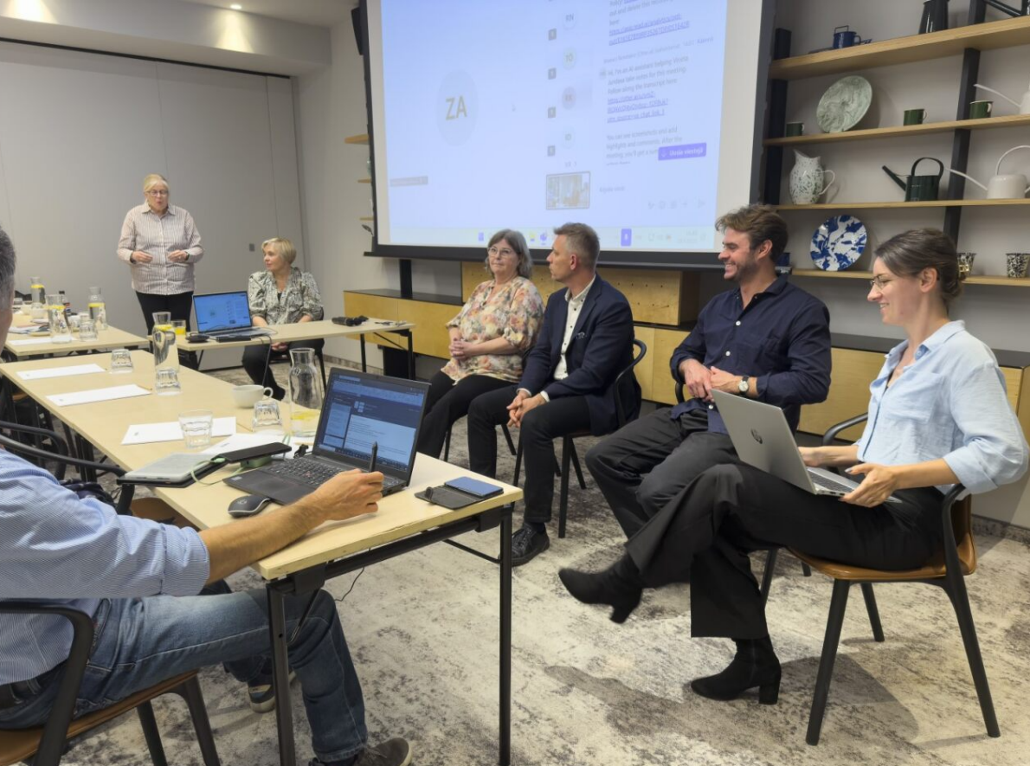
Figure 2. Workshop panel discussion, exploring the challenges and opportunities of composite recycling

The Danish Technological Institute (DTI) followed with its presentation, “Chemical Recycling of Composites”, focusing on solvolysis as a key solution for recycling thermoset-based composites. DTI’s Circular Resources unit develops chemical and lifecycle-based circular economy solutions. Solvolysis breaks down polymer matrices using solvents and reagents, enabling the recovery and reuse of fibers and other materials. Two main strategic approaches were outlined: “Design for Recycling”, which develops future resin systems (e.g., Recyclamine, EzCyclo, vitrimers) designed for easy dismantling and recyclability, and “Addressing Legacy Composites”, which targets existing thermoset materials using high-temperature, pressure-resistant, and corrosion-resistant processes.
DTI demonstrated the method’s application in wind turbine blades and ski recycling. Epoxy degradation was achieved using sodium hydroxide and a ruthenium catalyst at 190 °C, while ski recycling proved both technically feasible and environmentally beneficial saving approximately 7 kg CO₂-equivalent per ski pair compared to landfilling. Although solvolysis remains economically challenging at small scales, automation and process scaling are expected to improve profitability. Labor and equipment costs currently dominate, while revenue comes mainly from the recovery of valuable materials such as metals and plastics.
In summary, solvolysis offers a technically viable and environmentally sound pathway for composite recycling but requires process optimization, value-chain development, and robust business models for commercialization. The key questions moving forward concern who will operate recycling systems and what incentives will drive their adoption. Collaboration across the value chain, designing products for recyclability, and supportive legislation are essential to realizing sustainable composite recycling.

The final workshop session featured an industry perspective on solvolysis, with speakers from NOMA Resins and Podcomp.
NOMA Resins develops innovative, eco-friendly composite solutions using recycled carbon and glass fibers combined with bio-based epoxy resins. Their research focuses on chemical recycling of cured composites, epoxy porosity analysis, and adhesion promoter testing. NOMA’s products demonstrate excellent mechanical performance and a reduced carbon footprint composites can contain up to 50% recycled material and are produced in compliance with the ECR R118 standard. The company utilizes various molding techniques, including compression molding, infusion, and hot-pressing, and offers specialized composites with fire-retardant, antistatic, and conductive properties. Examples include inspection hatches made from recycled composite combined with polyurethane layers. NOMA’s technology aims to minimize waste and lower the environmental impact of the composite industry.
Podcomp, a Swedish composite manufacturer with 45 employees, specializes in bathroom modules but also produces train carriages and technical housing units. Its production relies on polymer composites made from polyester and vinyl ester resins, glass fiber mats, and recycled PET foam. However, the process generates significant waste such as sandwich panel cut-offs, glass mat scraps, and cured resin that currently ends up in landfills or energy recovery. Podcomp is exploring ways to reuse recycled fibers, particularly in mat or roll form, where either aligned or random fiber orientation can be used depending on application requirements. The fibers must be compatible with resins, mechanically durable, and support efficient manufacturing while maintaining documented environmental performance through Environmental Product Declarations (EPDs). For resin recycling, Podcomp highlighted the importance of quality consistency and carbon footprint reduction, noting that the use of recycled chemicals depends largely on resin producers. The company’s overall goal is to reduce its environmental impact by integrating recycled materials that meet both technical and sustainability standards.
The workshop concluded with a panel discussion on the challenges and opportunities in fiber-reinforced composite recycling. Participants debated which factors technology, economics, regulation, or market demand serve as the greatest enabler or barrier to scaling up recycling. From a technological perspective, the discussion focused on the current limitations of chemical recycling methods such as solvolysis and the breakthroughs needed for industrial implementation. From the industrial viewpoint, standards and certifications were seen as crucial for improving the acceptance of recycled materials in supply chains. The conversation also covered customer willingness to pay for sustainable materials and the most promising application areas, such as the automotive, wind energy, and aerospace sectors.
Regulatory perspectives emphasized policy instruments like producer responsibility schemes, subsidies, and mandatory recycling targets as key tools for accelerating the transition. Finally, the role of industrial infrastructure and new business models linking waste collectors, chemical recyclers, and manufacturers was highlighted as critical to ensuring raw material availability, process efficiency, and market acceptance. Audience questions centered on scaling technologies, the real-world impact of certifications, and the effectiveness of policy incentives in promoting a viable circular economy for composites.

