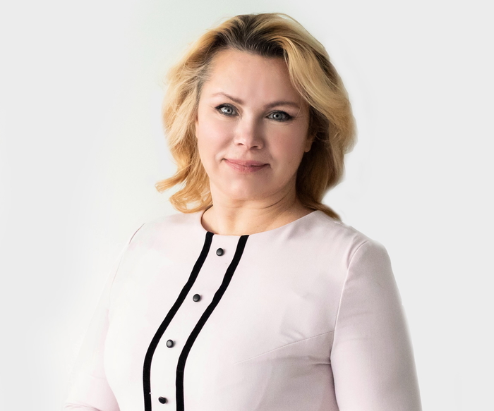

Alvija Šalaševičienė, the Director of KTU Food Institute. Photo: KTU.